Artificial Intelligence Lab

GitHub Assignment

(Forking & PR)



Department of Cyber Security

HITEC University Taxila

GitHub Forking & Pull-Request

Objective
- To understand the basics Forking with Examples
- Contributing to open-source projects
- Experimenting with changes
- Creating your own version

Software
- Python, Pycharm or VS-Code IDE

Theory

Forking
Forking is the act of creating a personal, independent copy of an existing repository on GitHub, under your own account.
When you fork a repository:
- You get a full replica of the code, commit history, branches, and issues (at the time of forking).
- This copy lives at: Mubshr07/ArtificialIntelligence-HITEC-Fall2025: A repo for subject material and Learning Git, GitHub, process Automation, Contribution and Collaboration.
- You have full ownership and write access to your fork.
- The original repository (called upstream) remains unchanged.
Important: Forking is a GitHub (or Git hosting platform) feature, not a native Git command. Git itself doesn’t have “fork”—this is a social/collaboration layer added by platforms like GitHub, GitLab, and Bitbucket.
Why Do We Fork? The Philosophy Behind It
Forking enables decentralized, permissionless collaboration. It’s foundational to open-source culture.
Key Use Cases:
Scenario | Explanation
Contribute to Open Source | You don’t need write access to the original repo. Just fork, change, and propose via Pull Request.
Experiment Safely | Try radical changes, break things, or prototype—without affecting the main project.
Create a Derivative Project | Build your own version (e.g., add features, relicense, or pivot the purpose).
Backup or Archive | Keep a personal snapshot of a project you rely on.

💡 GitHub’s slogan could be: “Fork, don’t ask.” — Empowering contributors without gatekeeping.

Forking vs. Cloning vs. Branching
Term | What It Does | Scope | Ownership
Clone | Downloads a repo to your local machine | Local only | No change in ownership
Branch | Creates a parallel version within the same repo | Same repo | Same permissions as original
Fork | Creates a new repo under your account on GitHub | Remote (new repo) | Full ownership

Key Insight:
- Branching = Collaboration within a team that shares a repo.
- Forking = Collaboration across trust boundaries (e.g., strangers on the internet).

Pull Request
A Pull Request (PR) is a proposal to merge your changes from one branch (usually in your fork or feature branch) into another branch (typically the main or develop branch of a project).
It’s the central mechanism for code review, discussion, and collaboration on GitHub, GitLab, Bitbucket, and other Git platforms.
Think of it like saying: “Hey team! I made some changes. Please review them and pull them into the main project.”

Why Is It Called a “Pull” Request?
Even though you push your changes to your branch, you’re asking the maintainers of the target repository to pull (i.e., fetch and merge) your changes into their codebase.
So:
✅ You push your code to your branch
➡️ You request that they pull it into theirs

When Do You Create a Pull Request?
Common scenarios:
- Fixing a bug
- Adding a new feature
- Improving documentation
- Updating dependencies
- Refactoring code
You create a PR only after:
- Forking a repo (if contributing externally) or creating a feature branch (if you have direct access)
- Making changes
- Committing and pushing those changes to your branch

Your Assignment — Step by Step

Click "Fork":
On any public (or accessible private) GitHub repository, click the Fork button (top-right).
→ GitHub creates a copy under your account (e.g Mubshr07/ArtificialIntelligence-HITEC-Fall2025: A repo for subject material and Learning Git, GitHub, process Automation, Contribution and Collaboration.).

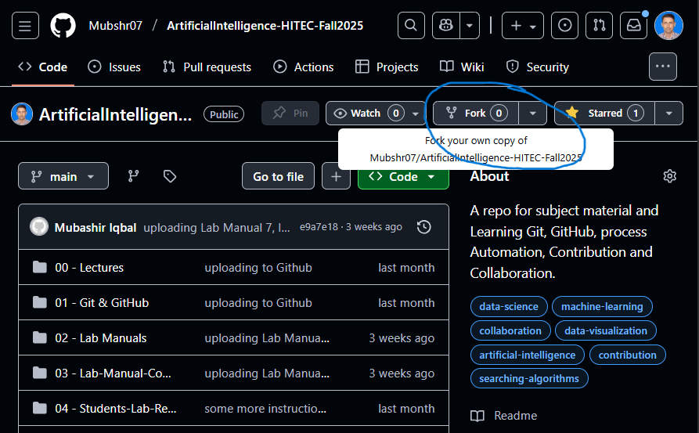
Clone Your Fork Locally
git clone https://github.com/Mubshr07/ArtificialIntelligence-HITEC-Fall2025

Add the Original as "Upstream" (Optional but Recommended):
This lets you sync updates from the original repo:
git remote add upstream https://github.com/Mubshr07/ArtificialIntelligence-HITEC-Fall2025
You can verify with:
git remote add -v

Create a New Branch
Never work on main/master! Always use a feature branch.
git checkout -b 24-CyS-***
(Use a clear, descriptive branch name)
But for this assignment only use your HITEC Registration number e.g 24-CyS-001, 24-CyS-002, 24-CyS-003, etc

Make Your Changes
- Make a Folder with your registration number inside the “04 - Students-Lab-Report-Submissions” Folder. (Some Folders are already only for reference)
- 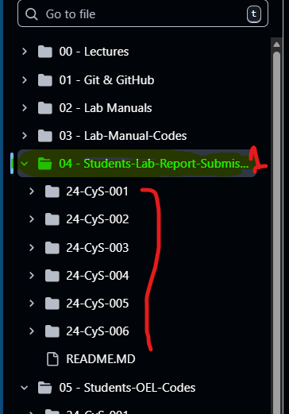
- Add your Lab Manual Code Files in Respective Folder
- Edit files in your code editor
- Add new features, fix bugs, update docs, etc.
- There are also separate main-Folders for OEL and Project
  - For OEL: “05 - Students-OEL-Codes”
  - For Project: “06 - Students-Semester-Project-Submission”
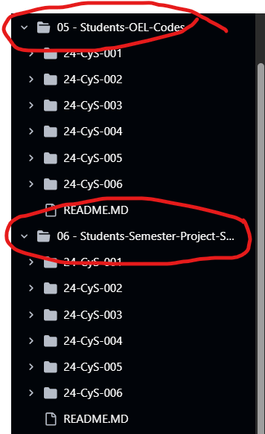
Just Make sure your Created a Branch with your HITEC-Registration No and then make Folder in respective Tasks (Lab, OEL, Project)

Stage and Commit Your Changes
git add .
git commit -m "Added all files of task (Lab, OEL, Project) "

💡 Write clear, concise commit messages.

Push Your Branch to Your Fork
git push origin 24-CyS-0**
This pushes your new branch to your fork on GitHub (your-username/project)

Open a Pull Request (PR)
- Go to your fork on GitHub: github.com/your-username/ArtificialIntelligence-HITEC-Fall2025
- GitHub will often show a banner: “Your recently pushed branches: 24-CyS-0** — Compare & pull request”
- Go to GitHub → your repository (or fork)
- Click “Compare & pull request” (GitHub often shows this banner automatically)
- Select:
  - Base: the branch you want to merge into (e.g., main)
  - Compare: your branch with changes (e.g., fix-typo)
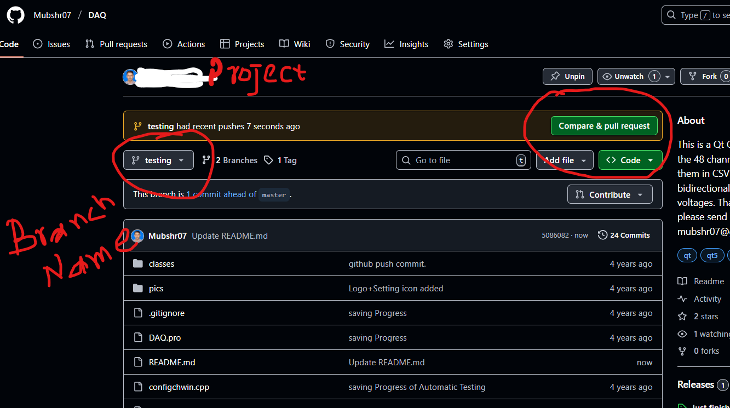
You Describe Your Changes
- Write a clear title: fix: correct spelling in installation guide
- Add a description:
  - What was changed?
  - Why was it changed?
  - Any related issues? (e.g., Closes #42)
  - Screenshots (if UI change)
Team Reviews the PR
- Maintainers or peers:
  - Read the code
  - Suggest improvements
  - Approve or request changes
- GitHub shows diffs (line-by-line changes)
You Respond to Feedback
- Make more commits if needed
- Push them to the same branch → they auto-update the PR
PR Is Merged (or Closed)
- If approved → maintainer clicks “Merge”
- Your changes become part of the target branch!

Conclusion

